**DAY 4**

1.     List all customers and the products they ordered with the order date. (Inner join)

**Tables used:** customers, orders, order_details, products

**Output should have below columns:**

    companyname AS customer,

    orderid,

    productname,

    quantity,

    orderdate

SELECT

c.company_name AS customer,

o.order_id,

p.product_name,

od.quantity,

o.order_date

FROM customers c

JOIN orders o ON c.customer_id = o.customer_id

JOIN order_details od ON o.order_id = od.order_id

JOIN products p ON od.product_id = p.product_id;

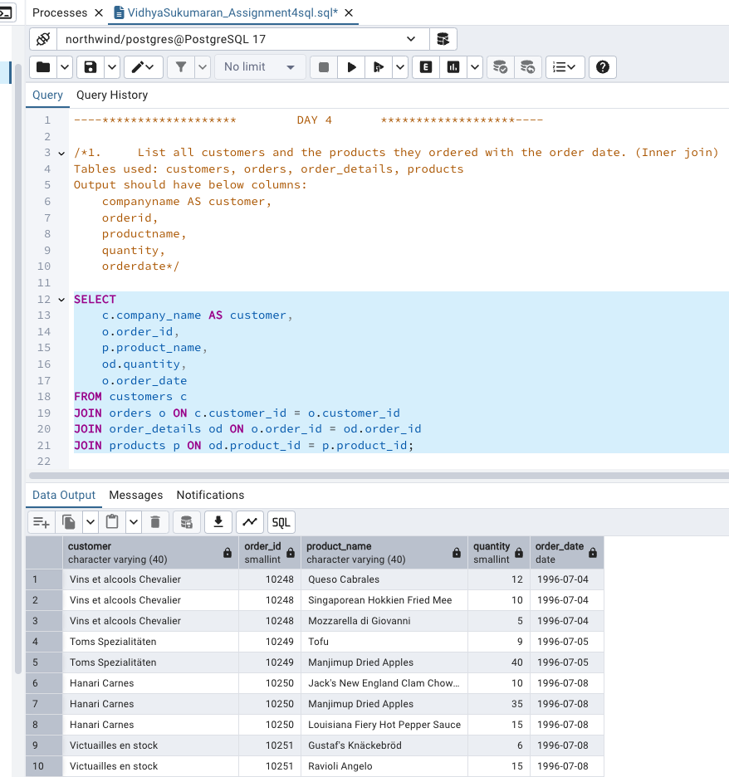

2.     Show each order with customer, employee, shipper, and product info — even if some parts are missing. (Left Join)

**Tables used: orders, customers, employees, shippers, order_details, products**

**SELECT**

**o.order_id,**

**c.company_name AS customer,**

**e.first_name || ' ' || e.last_name AS employee,**

**s.company_name AS shipper,**

**p.product_name,**

**od.quantity**

**FROM orders o**

**LEFT JOIN customers c ON o.customer_id = c.customer_id**

**LEFT JOIN employees e ON o.employee_id = e.employee_id**

**LEFT JOIN shippers s ON o.ship_via = s.shipper_id**

**LEFT JOIN order_details od ON o.order_id = od.order_id**

**LEFT JOIN products p ON od.product_id = p.product_id;**

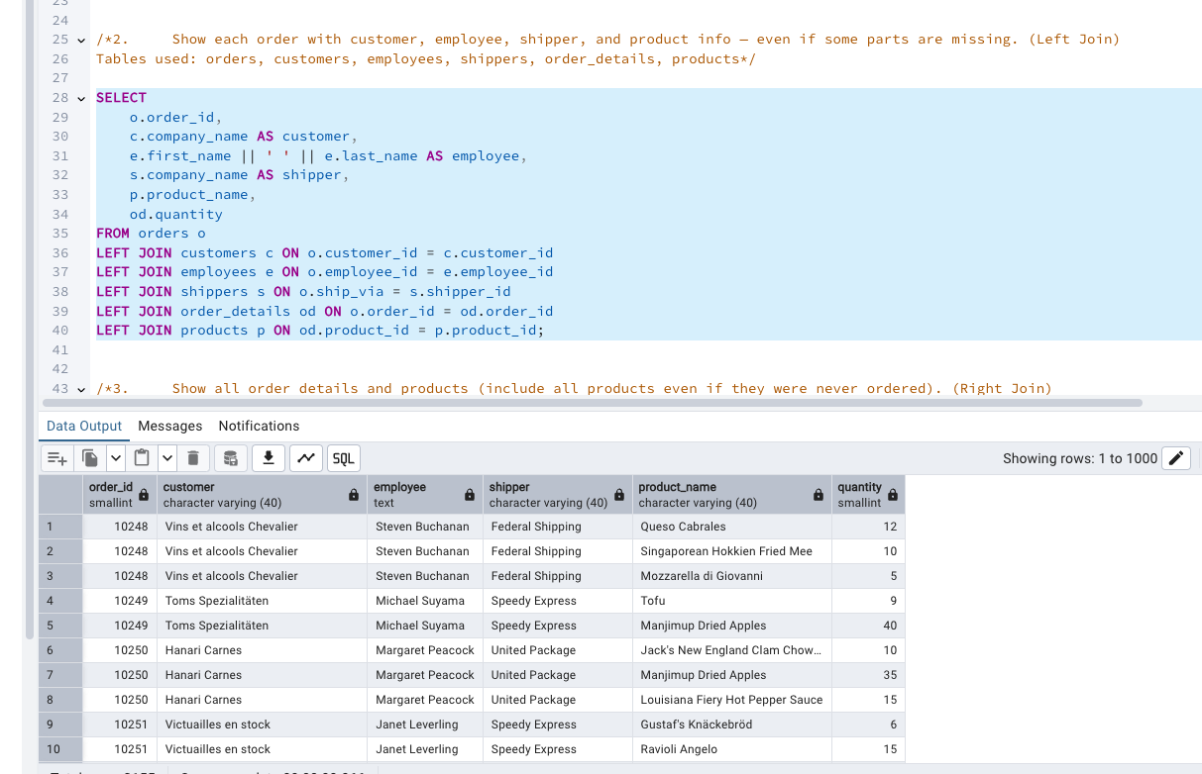

3.     Show all order details and products (include all products even if they were never ordered). (Right Join)

**Tables used: order_details, products**

**Output should have below columns:**

    orderid,

    productid,

    quantity,

    productname

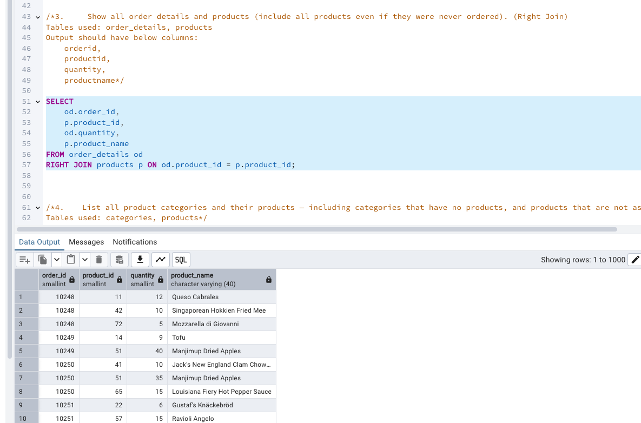

4. List all product categories and their products — including categories that have no products, and products that are not assigned to any category.(Outer Join)

**Tables used: categories, products**

**SELECT**

**c.category_name,**

**p.product_name**

**FROM categories c**

**FULL OUTER JOIN products p ON c.category_id = p.category_id;**

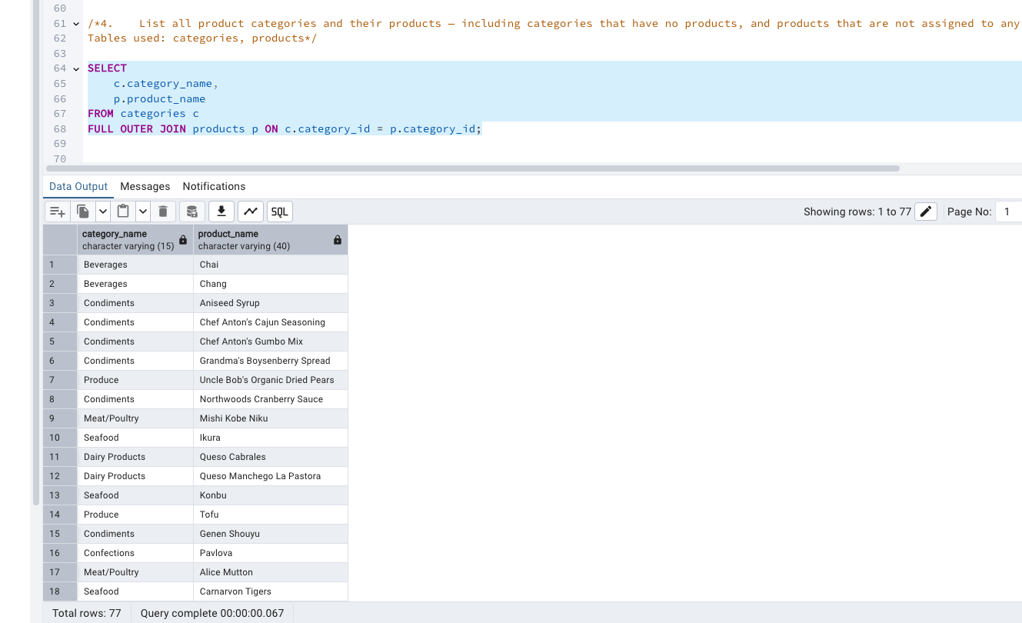

5. Show all possible product and category combinations (Cross join).

 SELECT

c.category_name,

p.product_name

FROM categories c

CROSS JOIN products p;

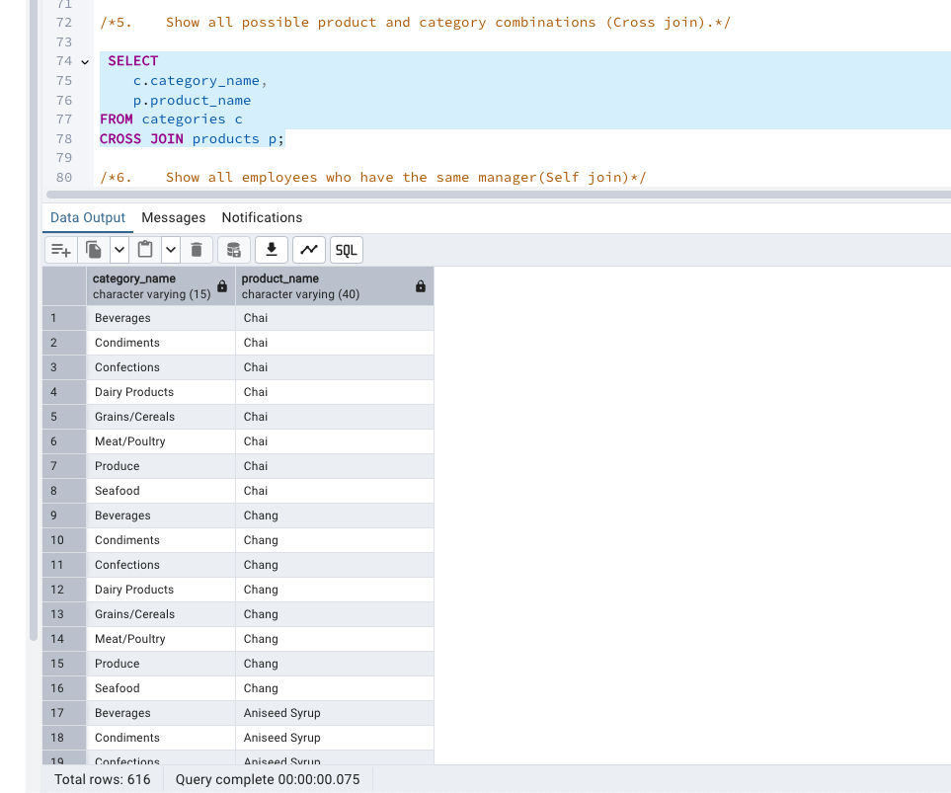

6. Show all employees who have the same manager(Self join)

 SELECT

e1.first_name || ' ' || e1.last_name AS employee,

e2.first_name || ' ' || e2.last_name AS coworker,

e1.reports_to AS manager_id

FROM employees e1

JOIN employees e2 ON e1.reports_to = e2.reports_to

WHERE e1.employee_id <> e2.employee_id;

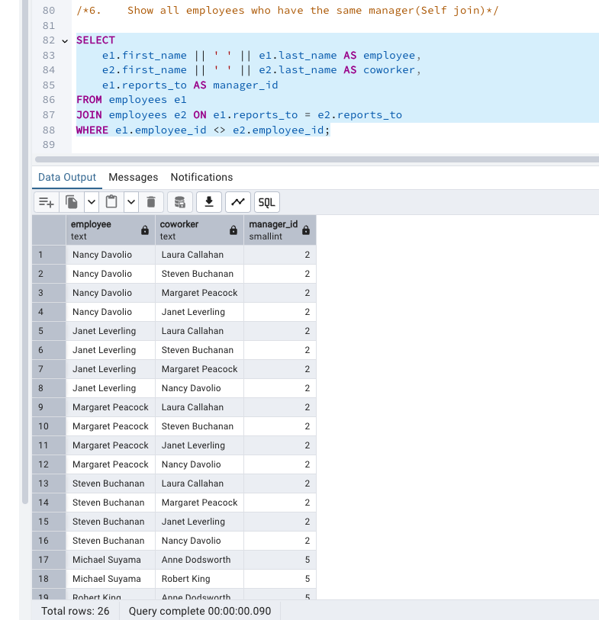

 7. List all customers who have not selected a shipping method.

**Tables used:** customers, orders

**(Left Join, WHERE o.shipvia IS NULL)**

SELECT

c.company_name

FROM customers c

LEFT JOIN orders o ON c.customer_id = o.customer_id

WHERE o.ship_via IS NULL;

